pasted-image.tiff

**5th Sunday after Pentecost**

**CHRIST LUTHERAN CHURCH** | Lodi, California

*June 23, 2024*

**WELCOME TO WORSHIP**

Welcome to Christ Lutheran Church. We pray that your soul will be strengthened by the good news about God’s grace, love, and forgiveness given to us. If you would like to learn more about our church, please speak with our pastor or one of our members after the service.

* **Bathrooms** are located in the fellowship hall. A changing table is located in the women’s bathroom.

**WORSHIP THEME**

The Lord answers us in our affliction.Sometimes the circumstances of life are out of our control and challenge our faith. The fact that Christ lives and lives in us, the fact that he rules all things for our good, is no guarantee that we will never face fear and disaster. Quite the contrary, he has promised us that we will have an abundance of troubles in this life. This Sunday’s reading shows us one particular aspect or fruit of faith: We trust in him when all the outward evidence argues against trust in him



***The Common Service***

*The high and holy worship of God is faith in Jesus Christ. Such faith is created and sustained by God’s service to us (the German, “Gottesdienst,” “The Divine Service”). In the Divine Service, the Lord comes to us in His Word and Sacrament to bless and enliven us with His gifts. The Service is not something we do for God, but His service to us received in faith. The liturgy is God’s work. He gives, we receive.*

**HYMN** *Be Still, My Soul***| CW 847**

**INVOCATION**

M: In the name of the Father, and of the Son ✙ and of the Holy Spirit

**C: Amen.**

**CONFESSION**

*From God’s Word we know that wherever God puts His name, there He is to bless. In the Old Testament the temple was the place where God graciously caused His name to be present (1 Kings 8:27-30).*

*God has put His name —Father, Son, and Holy Spirit—on us in Holy Baptism. The Divine Service begins with the Invocation, the words spoken over us at our baptisms. Every Divine Service is for the hallowing of the Lord’s name, which the Small Catechism reminds us is done “when the Word of God is taught in its truth and purity, and we, as the children of God, also lead holy lives according to it” (Matthew 28:18-20).*

M: Beloved in the Lord: let us draw near with a true heart and confess our sins to God our Father, asking him in the name of our Lord Jesus Christ to grant us forgiveness.

**C: Holy and merciful Father, I confess that I am by nature sinful, and that I have disobeyed you in my thoughts, words, and actions. I have done what is evil and failed to do what is good. For this I deserve your punishment both now and in eternity. But I am truly sorry for my sins, and trusting in my Savior Jesus Christ, I pray: Lord, have mercy on me, a sinner.**

# absolution

M: God, our heavenly Father, has been merciful to us and has given his only Son to be the atoning sacrifice for our sins. Therefore, as a called servant of Christ and by his authority, I forgive you all your sins in the name of the Father and of the Son ✙ and of the Holy Spirit.

**C**: **Amen**

# Kyrie

M: In peace let us pray to the Lord.

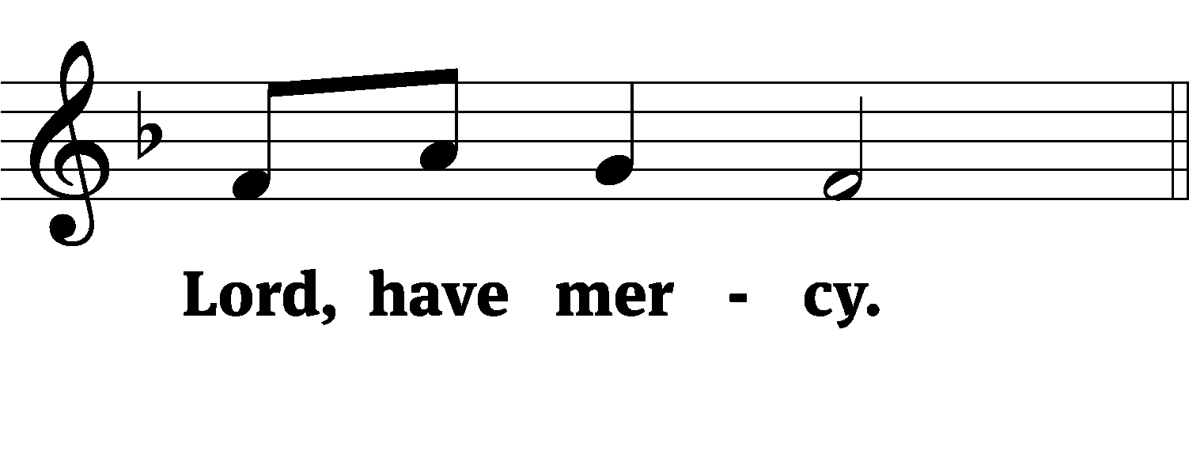

M: For the peace from above and for our salvation, let us pray to the Lord.

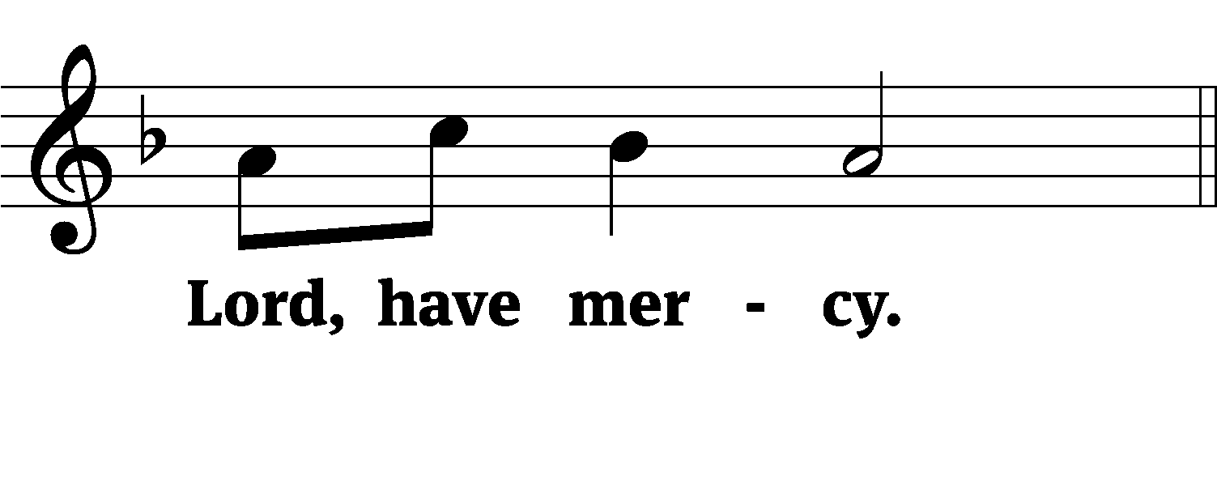

M: For the peace of the whole world, for the well-being of the Church of God, and for the unity of all, let us pray to the Lord.

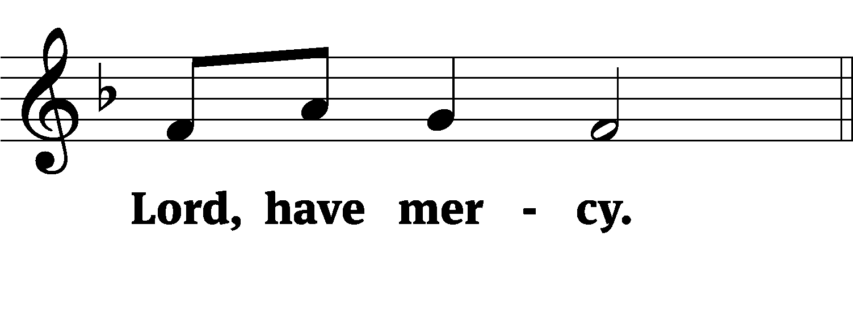

M: For this holy house and for all who offer here their worship and praise, let us pray to the Lord.

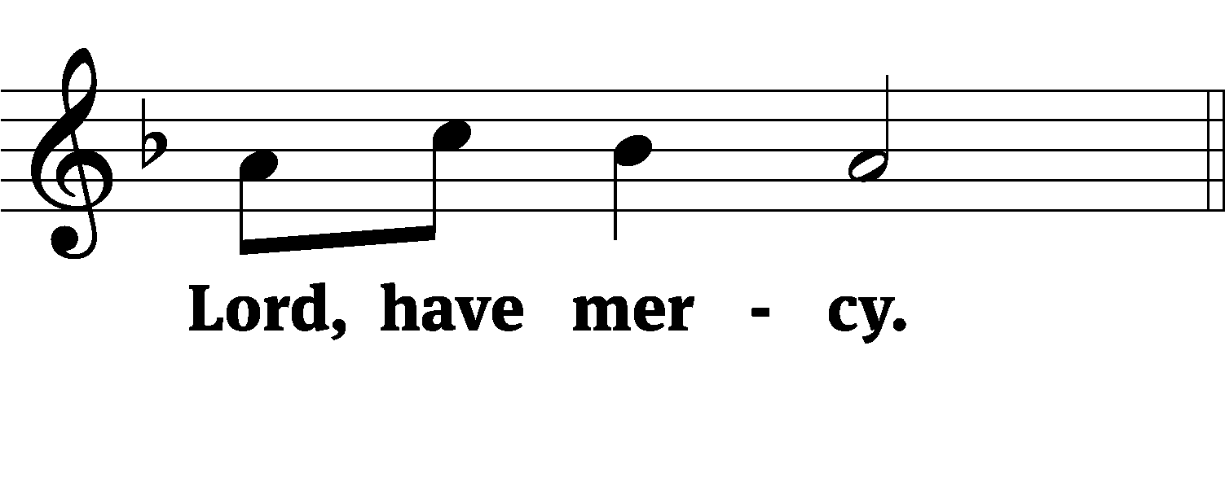

M: Help, save, comfort, and defend us, gracious Lord.

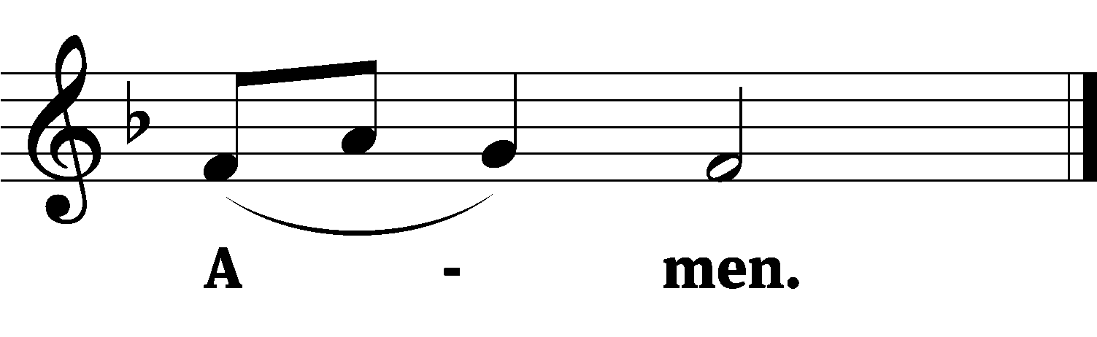

M: In the peace of forgiveness, let us praise the Lord.

**C:  Glory be to God on high,**

**and on earth peace, good will toward men.**

**We praise you, we bless you, we worship you,**

**We glorify you, we give thanks to you, for your great glory.**

**O Lord God, heavenly King, God the Father almighty.**

**O Lord, the only begotten Son, Jesus Christ;**

**O Lord God, Lamb of God, Son of the Father,**

**You take away the sin of the world; have mercy on us.**

**You take away the sin of the world; receive our prayer.**

**You sit at the right hand of God the Father; have mercy on us.**

**For you only are holy; you only are the Lord.**

**You only, O Christ, with the Holy Spirit,**

**Are most high in the glory of God the Father. Amen.**

**PRAYER OF THE DAY**

M: The Lord be with you.

**C: And also with you.**

M: Let us pray.

O Lord, our God, govern the nations on earth and direct the affairs of this world so that your Church may worship you in peace and joy; through your Son, Jesus Christ our Lord, who lives and reigns with you and the Holy Spirit, one God, now and forever.

**C: Amen**

**FIRST LESSON** *Job 38:1–11*

*The Lord answers Job out of the storm.*

**38**Then the Lord spoke to Job out of the storm. He said:

**2**“Who is this that obscures my plans  
    with words without knowledge?  
**3**Brace yourself like a man;  
    I will question you,  
    and you shall answer me.

**4**“Where were you when I laid the earth’s foundation?  
    Tell me, if you understand.  
**5**Who marked off its dimensions? Surely you know!  
    Who stretched a measuring line across it?  
**6**On what were its footings set,  
    or who laid its cornerstone—  
**7**while the morning stars sang together  
    and all the angels shouted for joy?

**8**“Who shut up the sea behind doors  
    when it burst forth from the womb,  
**9**when I made the clouds its garment  
    and wrapped it in thick darkness,  
**10**when I fixed limits for it  
    and set its doors and bars in place,  
**11**when I said, ‘This far you may come and no farther;  
    here is where your proud waves halt’?

**PSALM** *Psalm 46, CW’21*

**SECOND LESSON** *Acts 27:13-26*

*The Lord preserves Paul and his companions through a terrible storm.*

**13**When a gentle south wind began to blow, they saw their opportunity; so they weighed anchor and sailed along the shore of Crete. **14**Before very long, a wind of hurricane force, called the Northeaster, swept down from the island. **15**The ship was caught by the storm and could not head into the wind; so we gave way to it and were driven along. **16**As we passed to the lee of a small island called Cauda, we were hardly able to make the lifeboat secure, **17**so the men hoisted it aboard. Then they passed ropes under the ship itself to hold it together. Because they were afraid they would run aground on the sandbars of Syrtis, they lowered the sea anchor and let the ship be driven along. **18**We took such a violent battering from the storm that the next day they began to throw the cargo overboard. **19**On the third day, they threw the ship’s tackle overboard with their own hands. **20**When neither sun nor stars appeared for many days and the storm continued raging, we finally gave up all hope of being saved.

**21**After they had gone a long time without food, Paul stood up before them and said: “Men, you should have taken my advice not to sail from Crete; then you would have spared yourselves this damage and loss. **22**But now I urge you to keep up your courage, because not one of you will be lost; only the ship will be destroyed. **23**Last night an angel of the God to whom I belong and whom I serve stood beside me **24**and said, ‘Do not be afraid, Paul. You must stand trial before Caesar; and God has graciously given you the lives of all who sail with you.’ **25**So keep up your courage, men, for I have faith in God that it will happen just as he told me. **26**Nevertheless, we must run aground on some island.”

**VERSE OF THE DAY** *Philippians 2:8*

**Jesus humbled himself and became obedient to death, even death on a cross.**

**THE GOSPEL** *Mark 4:35–41*

*Jesus calms the wind and the waves.*

**35**That day when evening came, he said to his disciples, “Let us go over to the other side.” **36**Leaving the crowd behind, they took him along, just as he was, in the boat. There were also other boats with him. **37**A furious squall came up, and the waves broke over the boat, so that it was nearly swamped. **38**Jesus was in the stern, sleeping on a cushion. The disciples woke him and said to him, “Teacher, don’t you care if we drown?”

**39**He got up, rebuked the wind and said to the waves, “Quiet! Be still!” Then the wind died down and it was completely calm.

**40**He said to his disciples, “Why are you so afraid? Do you still have no faith?”

**41**They were terrified and asked each other, “Who is this? Even the wind and the waves obey him!”

M This is the Gospel of the Lord.

**C: Praise be to you, O Christ!**

**APOSTLES’ CREED**

**I believe in God, the Father Almighty,**

**maker of heaven and earth.**

**I believe in Jesus Christ, his only Son, our Lord,**

**who was conceived by the Holy Spirit,**

**born of the Virgin Mary,**

**suffered under Pontius Pilate,**

**was crucified, died, and was buried.**

**He descended into hell.**

**The third day he rose again from the dead.**

**He ascended into heaven**

**and is seated at the right hand of God the Father Almighty.**

**From there he will come to judge the living and the dead.**

**I believe in the Holy Spirit,**

**the holy Christian Church,**

**the communion of saints,**

**the forgiveness of sins,**

**the resurrection of the body,**

**and the life everlasting. Amen.**

**HYMN OF THE DAY** *A Vicious Storm, a Raging Sea***| CW 984**

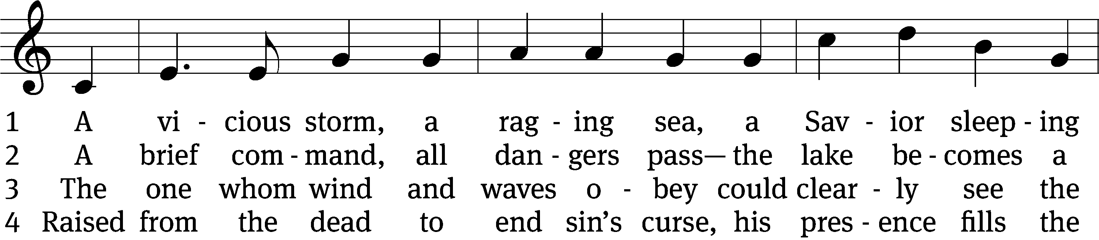

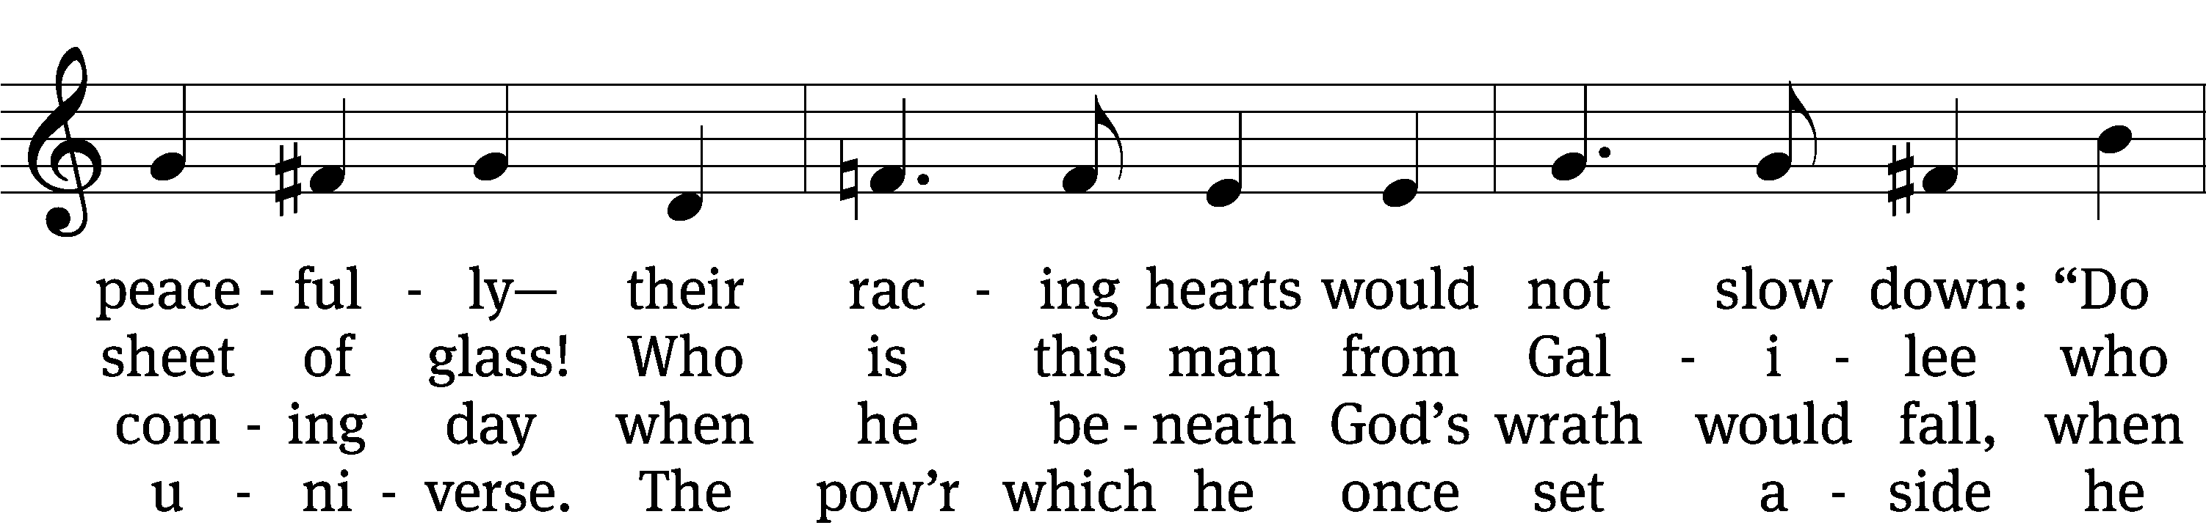

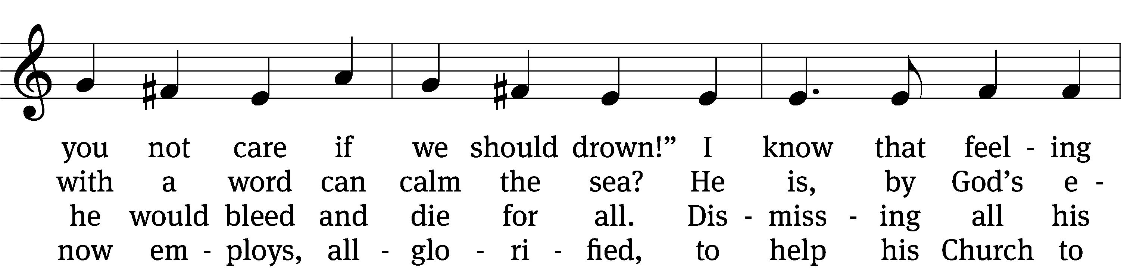

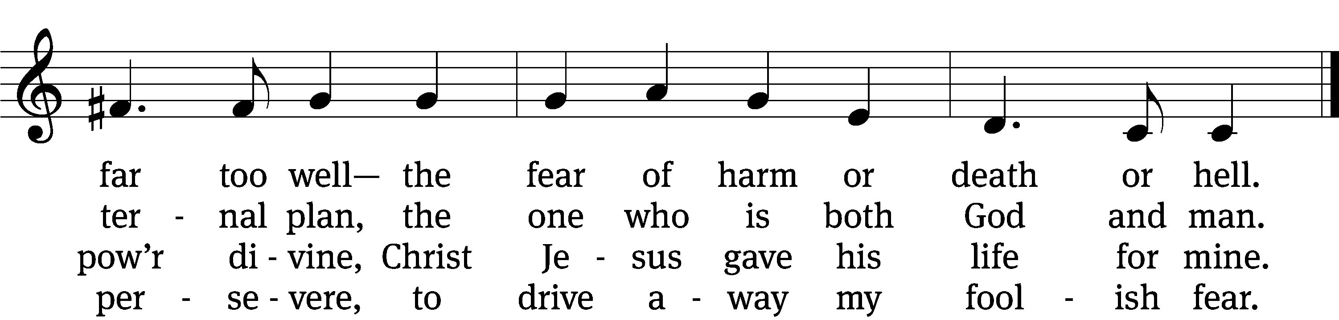

5 A boat, a storm, adrift again,  
they marshaled all their strength in vain.  
They saw the Lord; “A ghost!” they cried,  
and, sinking fast, one almost died.  
But he who walked out on the sea  
saved them from great catastrophe.

6 Lord Jesus Christ, when storms arise  
on you alone I’ll fix my eyes.  
Through Word and water, bread and wine,  
I hear you saying, “You are mine!”  
Your promises are strong to quell  
all fear of harm and death and hell.

Text: Michael D. Schultz, b. 1963 Tune: John B. Dykes, 1823–1876 Text: © 2009 Michael D. Schultz, admin. Northwestern Publishing House. Used by permission: OneLicense no. 718312 Tune: Public domain

**SERMON** *Job 38*

**OFFERTORY**

**C:  Create in me a clean heart, O God,**

**And renew a right spirit within me.**

**Cast me not away from your presence**

**And take not your Holy Spirit from me.**

**Restore unto me the joy of your salvation,**

**And uphold me with your free Spirit. Amen.**

**OFFERING**

*In response to God’s love and forgiveness, we give back a portion of what he has given us. The members of Christ Lutheran Church have joined to proclaim the gospel to this community. These offerings support that work. While our guests are welcome to participate, they should not feel obligated to do so.*

**PRAYER OF THE CHURCH**

M: We thank You, Lord, for Your steadfast love and Your wondrous works to the children of men. You hold power over wind and wave, sin and death. Deliver us from every trouble and distress, and bring us at last to our eternal haven. Lord, in Your mercy,

**C: Hear our prayer.**

M: God of our salvation, You preserved your Apostle and his companions on the sea and allowed Paul to continue to preach the gospel, even in dire circumstances. Support all Your ministers, and remove all obstacles from hearing and believing the Word they preach. Let Your grace be proclaimed through every hardship, struggle and suffering, and encourage us by the example of many saints to consider ourselves rich and alive despite every opposition, for since we have Christ, we possess everything. Lord, in Your mercy,

**C: Hear our prayer.**

M: Heavenly Father, open wide the hearts of Christians to one another, especially within the home and between neighbors. Let love be genuine, speech truthful and patience constant. Let us commend ourselves in everything as those known by God’s love and, therefore, unashamed to serve one another. Lord, in Your mercy,

**C: Hear our prayer.**

M: Almighty God, You rule this world by Your power. Give to our civil servants respect and recognition of Your creation and its nature. When they use the authority given them from above, let it be in accord with Your good design for our world and not the corruption of sin, which they are to rebuke for the good of their citizens. Lord, in Your mercy,

**C: Hear our prayer.**

M: Mighty Lord, You command wind and wave. Out of Your mercy, spare us from disaster. Give success to crops; send suitable rain for the earth; give protection to those endangered by storms on land, sea or air; and give us faith both to call to You in trouble and to trust that You will work everything for our good for the sake of Christ. Lord, in Your mercy,

**C: Hear our prayer.**

M: Gracious Father, You see that we are perishing, yet You bid us to set our fears aside and trust in You for the sake of Christ, by whose blood we have received peace for our troubled consciences. Do not reject our prayers for their faithlessness, but teach us to trust in You fully. Give Your protection and peace to those in need. Lord, in Your mercy,

**C: Hear our prayer.**

*Special intercessions may follow*

M: Hear us, heavenly Father, for the sake of Christ Jesus, our Lord, who lives and reigns with You and the Holy Spirit, one God, now and forever.

**C: Amen.**

**LORD’S PRAYER** *Matthew 6:9-13; Luke 11:2-4*

**C: Our Father in heaven, hallowed be your name,**

**your kingdom come, your will be done**

**on earth as in heaven.**

**Give us today our daily bread;**

**and forgive us our sins, as we forgive those**

**who sin against us;**

**and lead us not into temptation,**

**but deliver us from evil.**

**For the kingdom, the power, and the glory**

**are yours now and forever. Amen.**

**THE BLESSING**

M**:** The Lord bless you and keep you.

The Lord make his face shine on you and be gracious to you.

The Lord look on you with favor and ✙ give you peace.

**C: Amen.**

**CLOSING HYMN** *God Moves in a Mysterious Way***| CW’93 420**

**COPYRIGHT INFORMATION**

*Content requiring a copyright license is reproduced under OneLicense.net #A-718312. All rights reserved. The Common Service: Texts revised from The Lutheran Hymnal, 1941. Music revised by James Engel. Scripture Quotations: From the Holy Bible, New International Version (NIV 1984), © 1973, 1978, 1984 by Biblica, Inc.*



**13009 N. Elderberry Ct.**

**Lodi, CA 95242**

[www.christlodi.org](http://www.christlodi.org)

209-368-6250

Pastor Timothy Leistekow

**WELCOME TO CHRIST EV. LUTHERAN CHURCH!**

We preach a message of forgiveness, hope and peace

through the death and resurrection of Jesus Christ.

Families and individuals of all ages will find opportunities

both to grow and to serve.

Our mission statement:

**Look what Christ is doing!**

He binds us together in fellowship

He gathers us in for worship

He builds us up for service

He sends us out with the gospel

*“Now you are the body of Christ,*

*and each one of you is a part of it.”*

*(1 Corinthians 12:27)*